

School Of Engineering And Technology

Computer Science And Engineering Department

Navrachana University, Vadodara

Fourth Year B.Tech CSE (Semester 7)

Academic Year 2024-2025

Augmented & Virtual Reality (ARVR)

Course In-Charge: Professor Darshan Parmar

**Topic : Basketball VR Game**

Student Name: Manshi Singhi (21124029)

Date : 26/10/24

**Task 1: Set Up Your Unity Project & Configure the VR Environment**

* Installed Unity and click on New Project
* In templates, select 3D Core template and give your project a name and create project

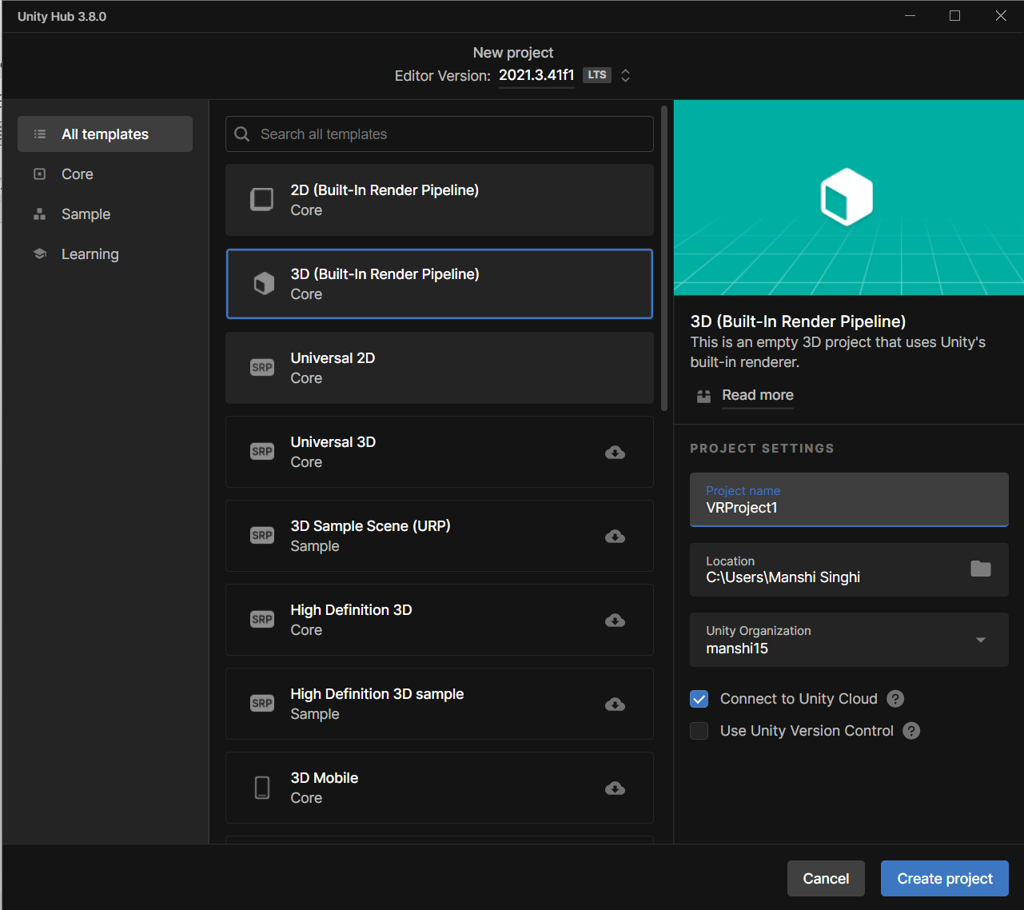

* In XR Plugin Management, add OpenXR

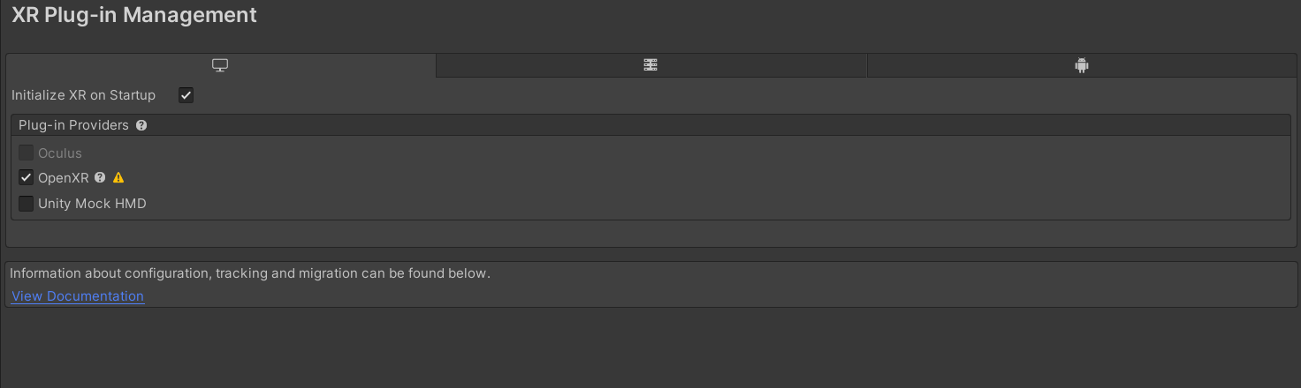

* Add enabled Interaction Profiles in windows and android frame

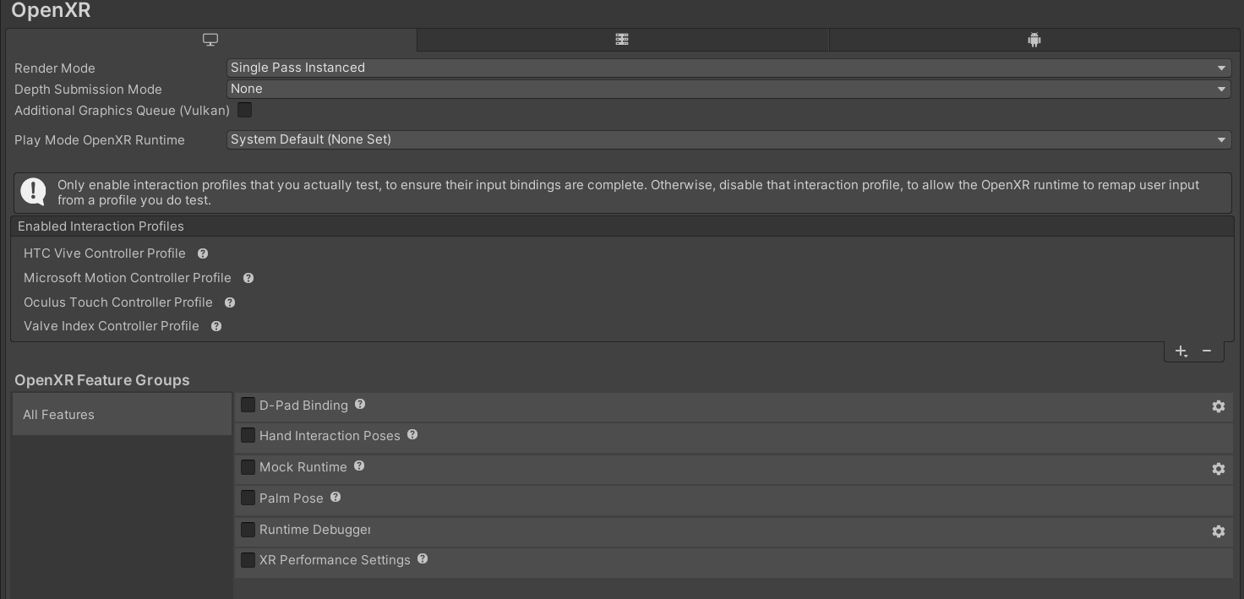

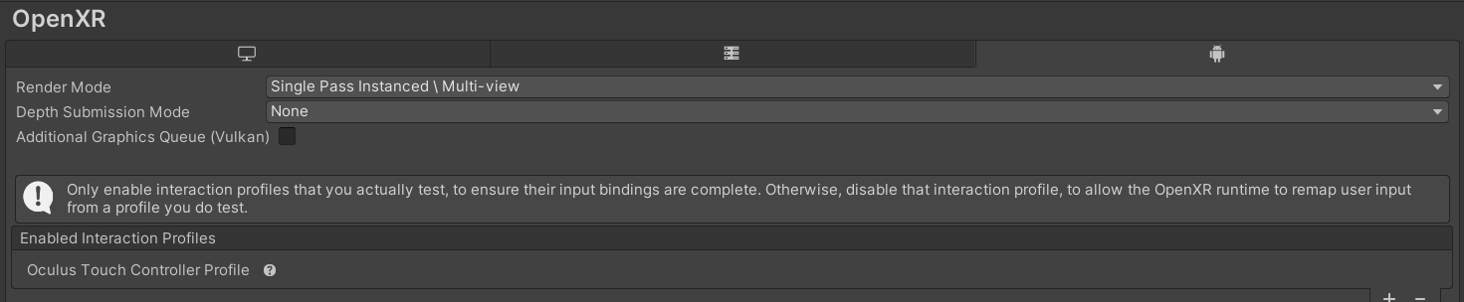

* Go to package manager and install XR Interaction Toolkit
* Also import Starter Assets inside the samples

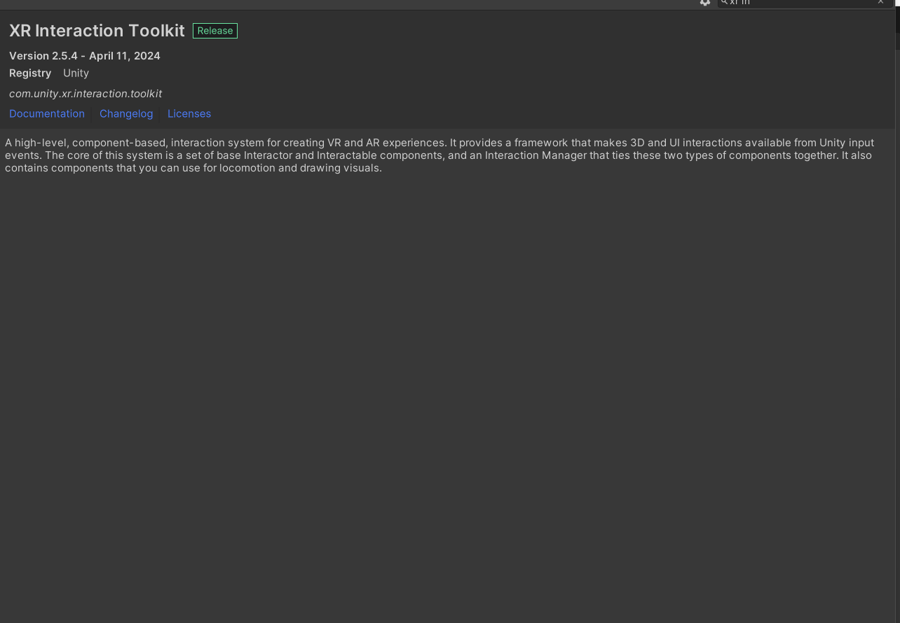

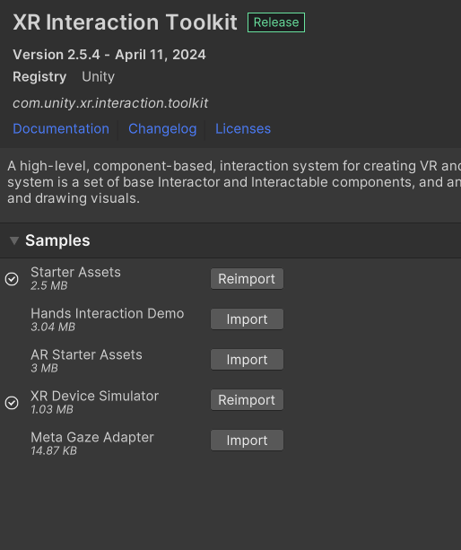

**Task 2: Create the Ground Plane and add a Skybox**

**● Create a larger ground area so player can move around**

**● You can use Terrain object for that**

* Create a terrain by right clicking on inspector window -> 3D Object ->Terrain so that the player can mode over that area.
* Import Fantasy Skybox FREE asset from Unity Asset Store

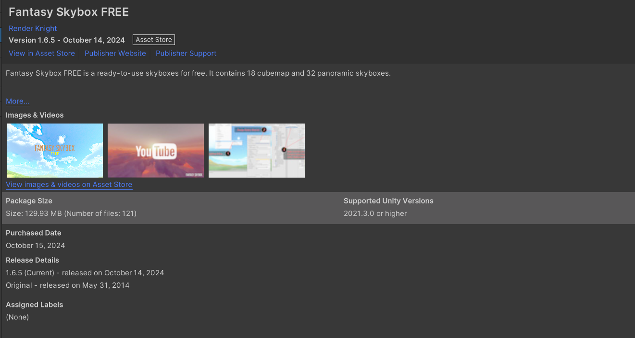

<https://assetstore.unity.com/packages/2d/textures-materials/sky/fantasy-skybox-free-18353>

* Open window -> Rendering ->Lighting ->Environment -> Skybox material and add the assets for skybox

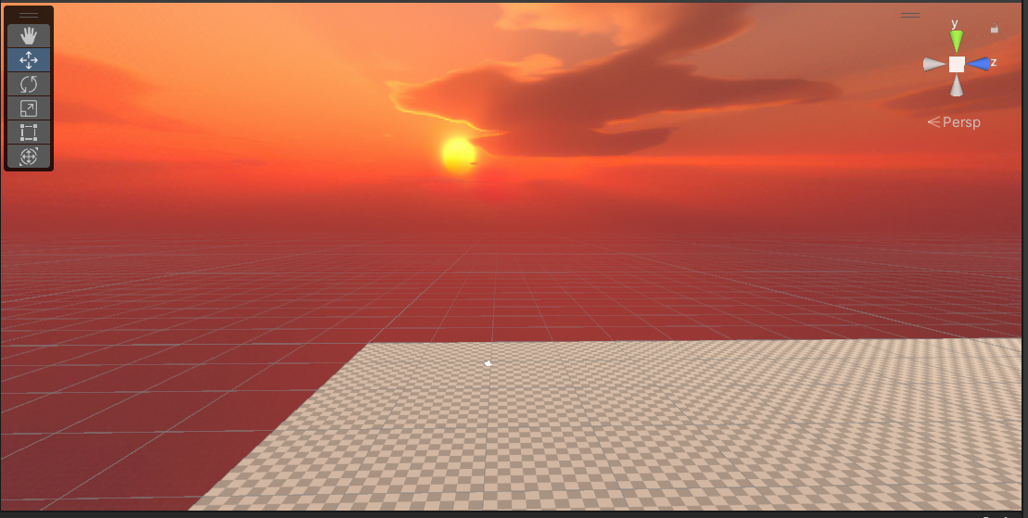

**Task 3: Add Environment Objects**

**● You can use Assets to create an engaging Environment**

**● Create a grabbable objects spawning at random locations**

* Import Toon City Pack asset for getting the basketball court.

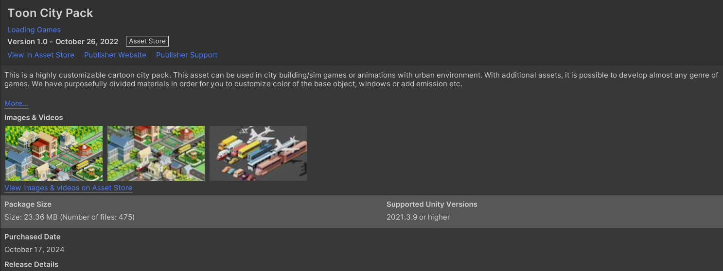

<https://assetstore.unity.com/packages/3d/environments/urban/toon-city-pack-234785>

* Import BasketballRing asset for the Basket ring and net.

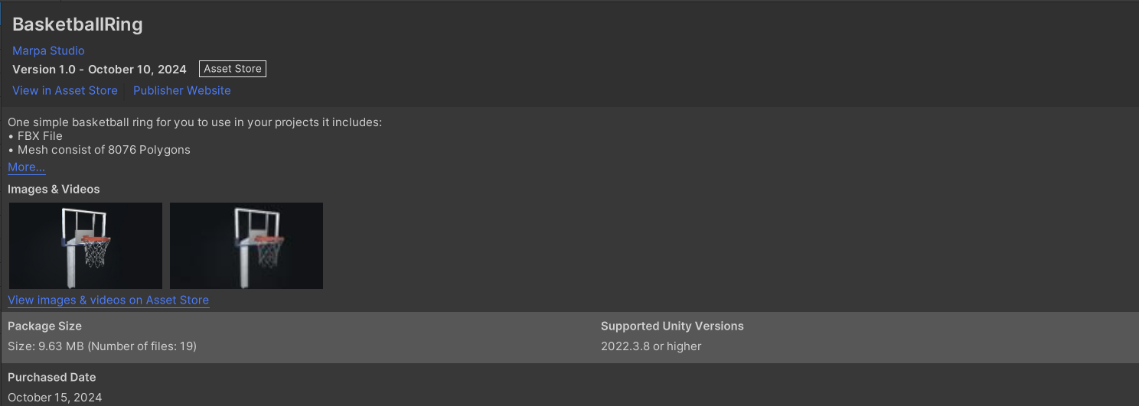

<https://assetstore.unity.com/packages/3d/props/basketballring-297800>

* Import Free Sport Balls asset for Basketball.

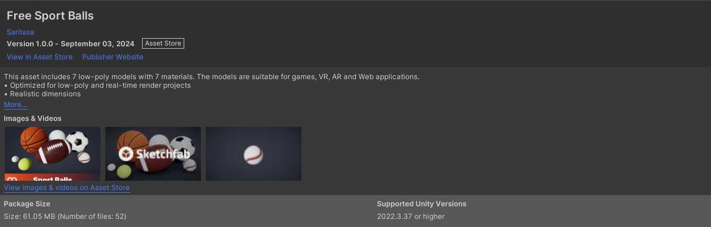

<https://assetstore.unity.com/packages/3d/props/free-sport-balls-293937>

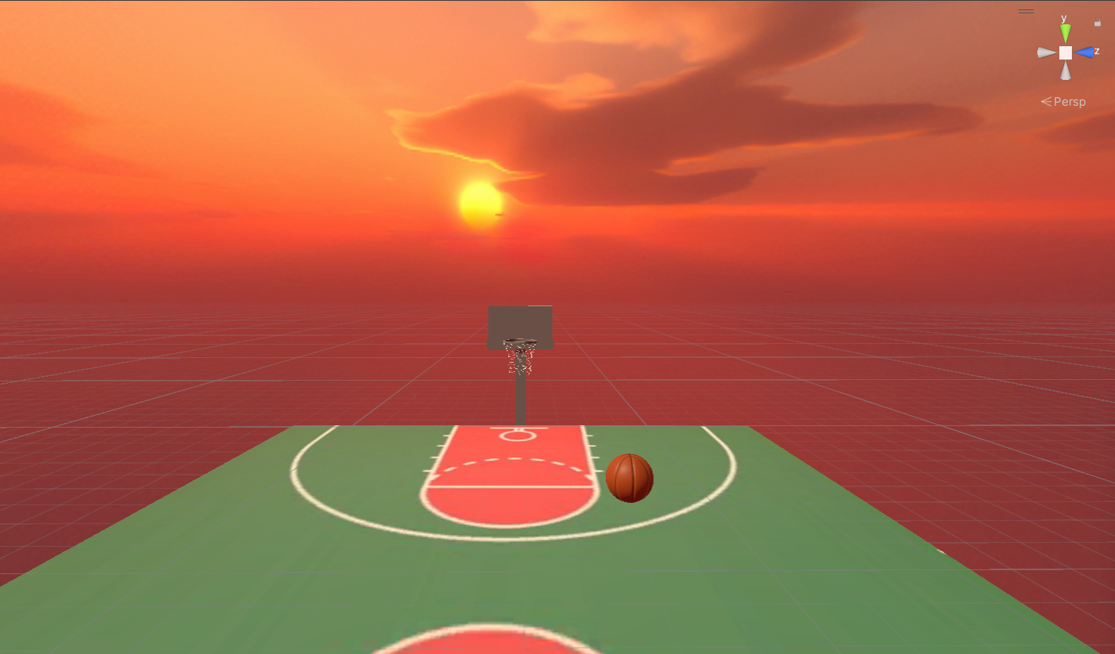

Adding the controller to interact with the objects

* Added XR Rig in inspector to add VR camera as well as the controllers.
* Make tracking origin mode as floor and click on 3 dot option of input action manager and add XRI default input actions

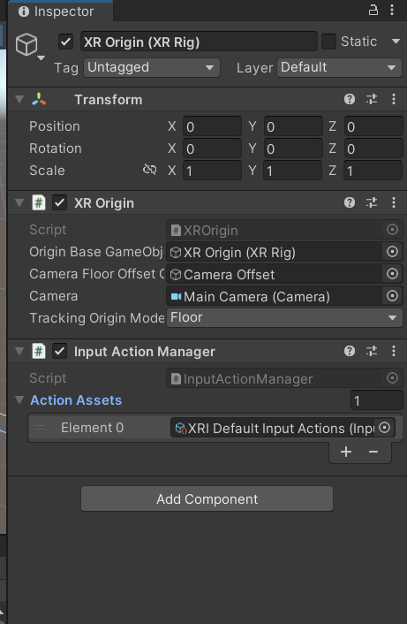

* In left controller add XRI default left controller by clicking on 3 dot line. Same for right controller.

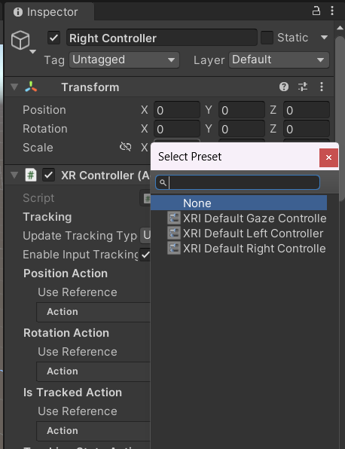

* Import Oculus Hand asset for creating hands for the controller

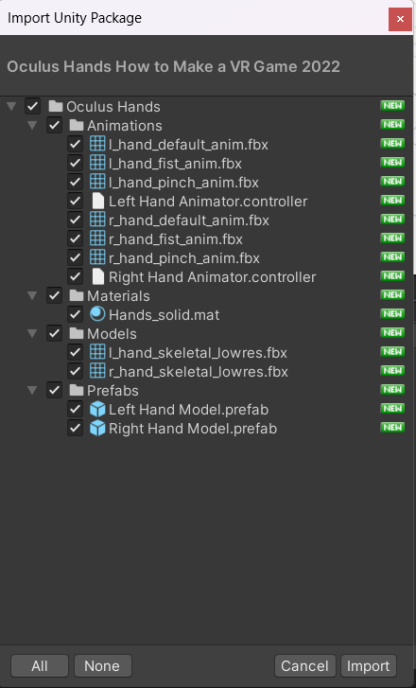

<https://drive.google.com/file/d/10b39IekUdpBHlcTslZ-BlNRyH5uqPUe1/view?usp=sharing>

* Drag left and right hands from oculus hand prefab to the left and right controllers

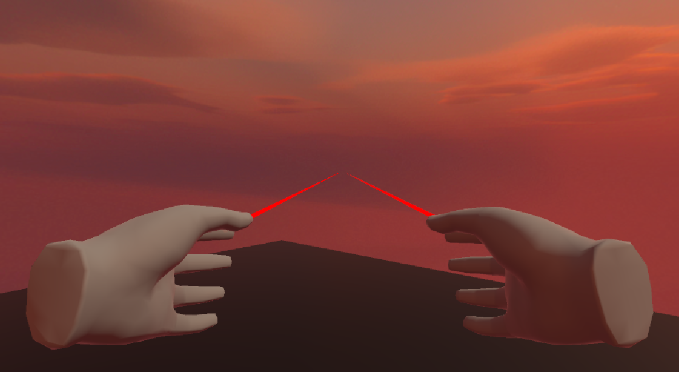

**Task 4: Configure Lighting and Shadows**

* Added a directional light element for the lightning (since it is an outdoor setup) and positioned it with the direction of my sun in the skybox.
* Changed the shadow type from no shadow to soft shadow.

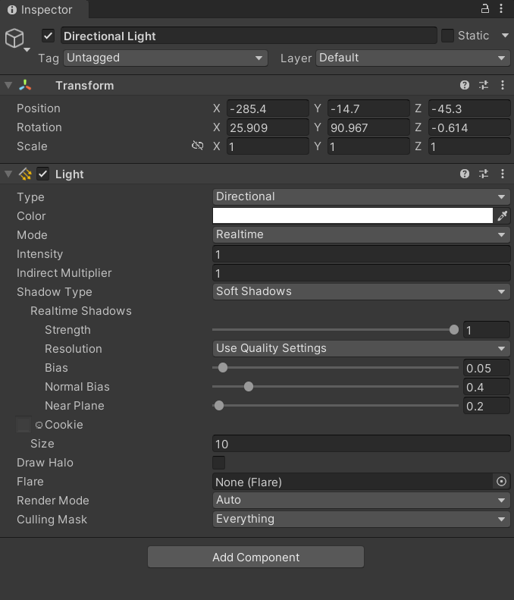

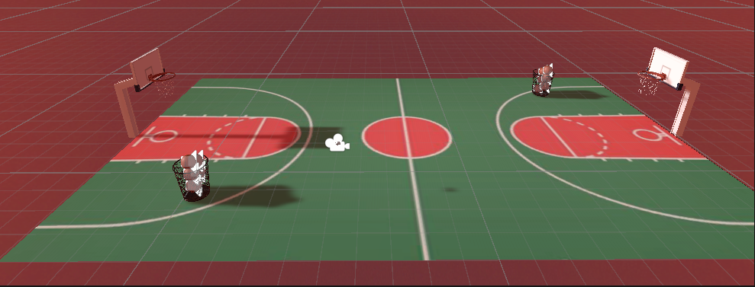

**Task 5: Add Audio**

* Download audio which you need to add to the game and drag it in the asset folder.

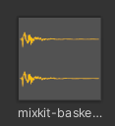

* In basketball, add audio source component. In audio clip , add the music you want to play. Disable on awake as we don’t want to play music when the game starts.

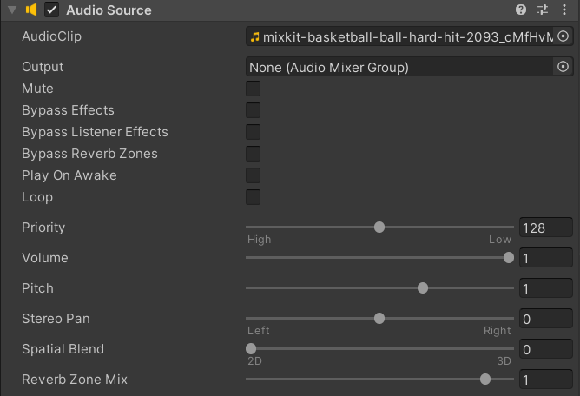

* Add a script for the bounce sound and attach the script as a component of the basketball.

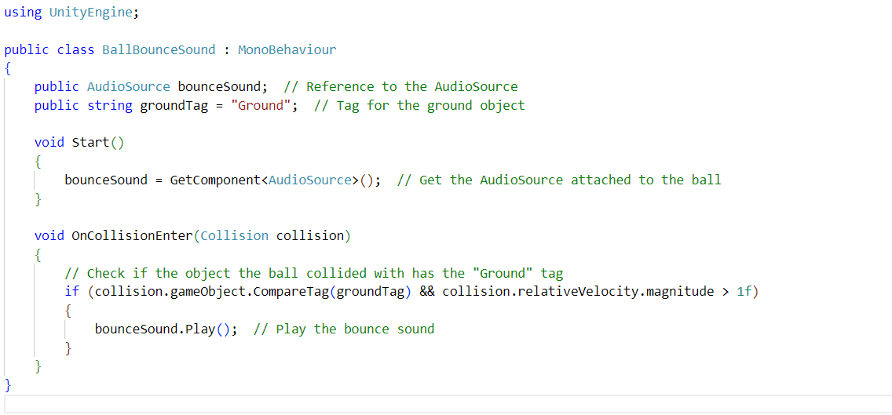

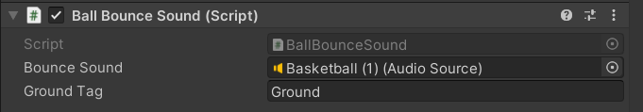

* This will play the audio whenever the ball touches the ground.

**Task 6: Implement Basic VR Interaction**

**● Create a Grabbable Object**

**● Add Grabbable and Grabber Components**

* Add sphere collider to both the hands(controllers) and set the radius to 0.1

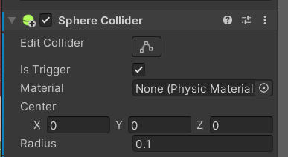

* We need to make basketball grabbable to we first need to add basketball prefab in our project
* Make sure that the object to be grabbed (basketball) should have rigid body as well as the collider.
* Also add the XR Grab interactable and set Movement Type to Velocity Tracking. Also enable smooth position and smooth rotation.
* Also change the throw components (like throw velocity scale, throw angular velocity, etc) as per your need.

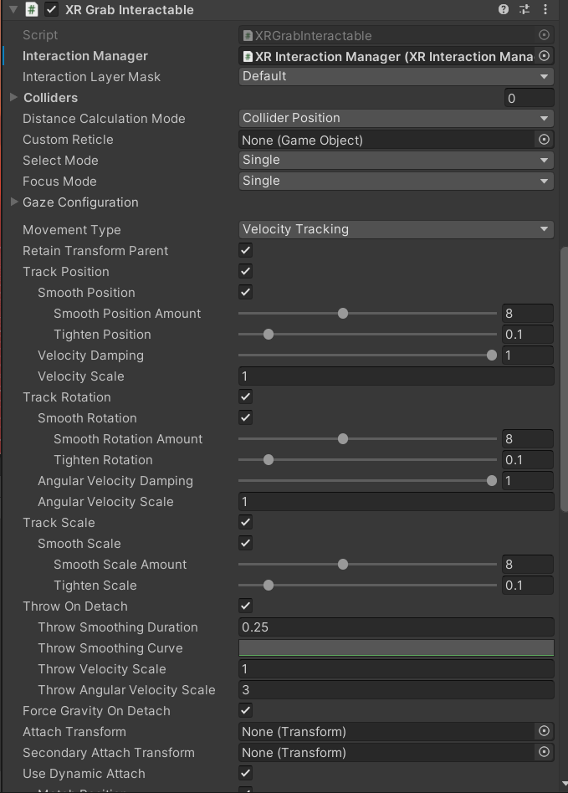

* Also added a script to show pinch and grip animation of hands when the ball is grabbed. Attached that script to left and right controller.

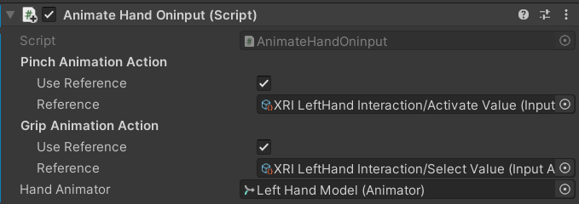

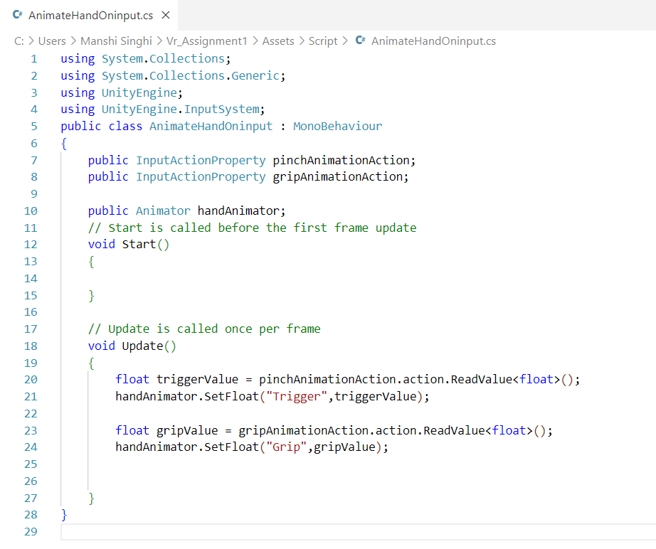

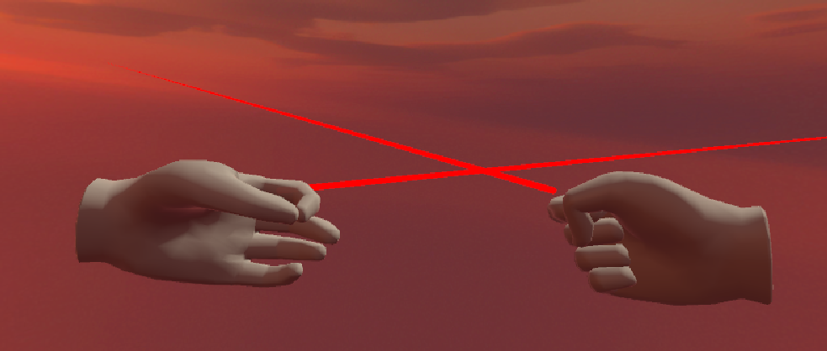

Pinch and grip animation on hand

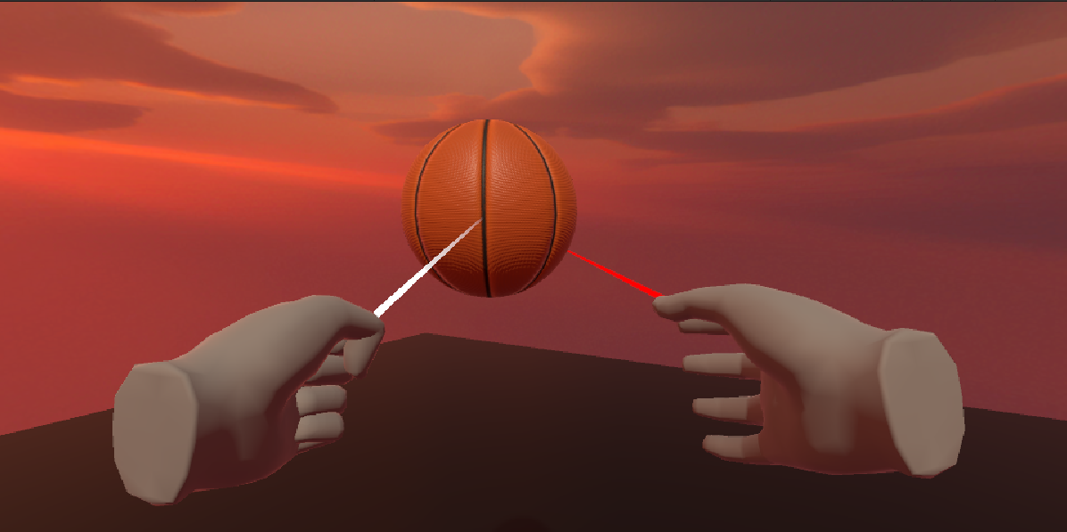

Ball grabbing and throwing

**Task 7: Write the VR Interaction script**

* I have added 4 scripts in my basketball game

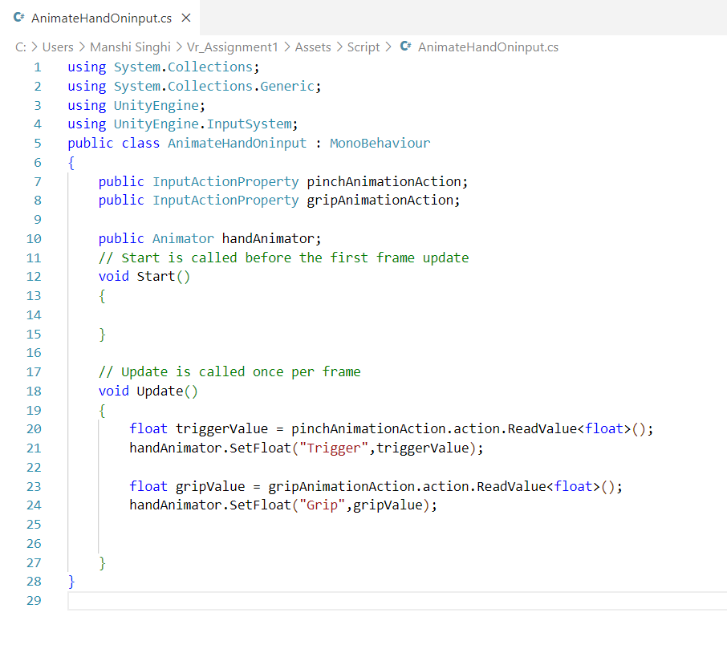

AnimateHandOnInput.cs

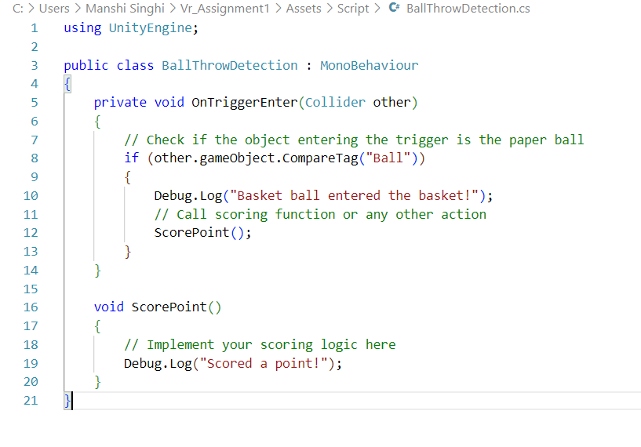  
BallThrowDetection.cs

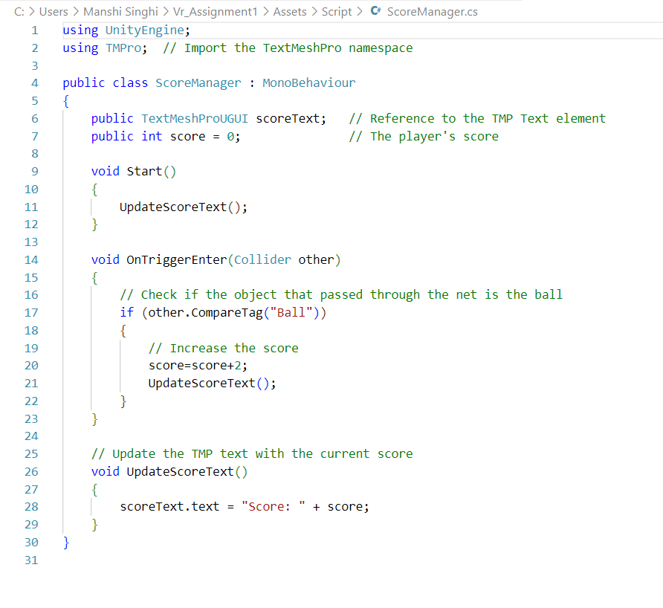  
ScoreManager.cs

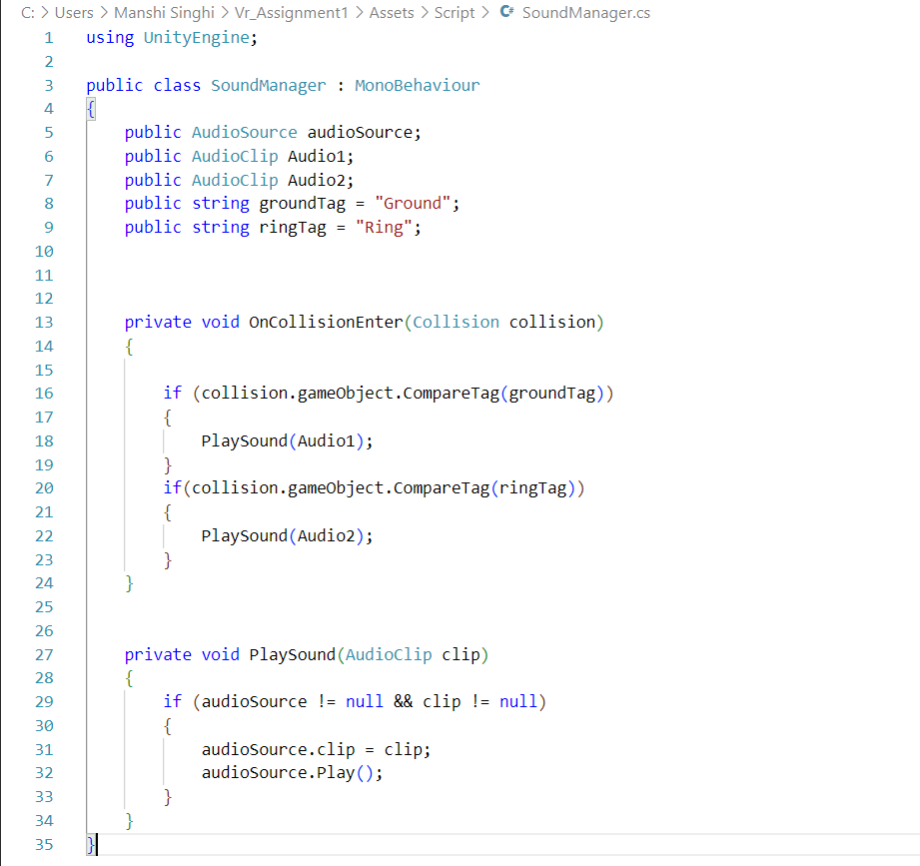  
SoundManager.cs

**Task 8: Create a scoring mechanism**

* Create a UI element to show the score text and position it based on user interface
* Write a script to update the score whenever user throws the ball into the net successfully

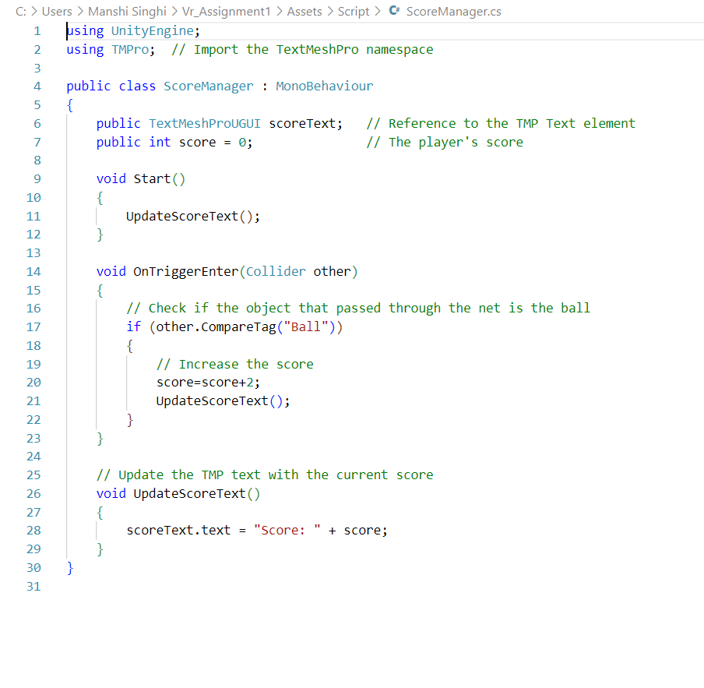

* Attach mesh collider to the net and enable convex and is trigger

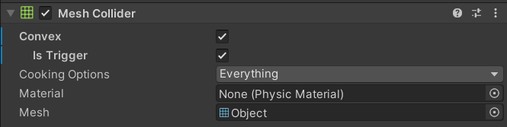

* Also attach the script to the net

